Assignment 9
Bharat Unnati AI Fellowship
CodeXpert

Assignment 9
Name: PRATHVIRAJ GOWDA
USN: 1CR22CD034
College: CMR INSTITUTE OF TECHNOLOGY

Topic:
Writing a Class Using Advanced OOP Features

Problem Statement
Wewillimplementan Object-Oriented Programming OOP) model for a Digital Library System. This program demonstrates:
Encapsulation → Hiding book availability status
Inheritance → Creating a specialized _{AudioBook} class from a general Book class
Polymorphism → Overriding the display method The implementation is done using Python.

Python Code Implementation
class Book:
# Class Variable (Shared among all Book objects) library_name = "Central City Library"
# Constructor def __init__(self, book_id, title, author):
self.book_id = book_id # Public variable self.title = title # Public variable self.author = author # Public variable self.__is_issued = False
# Private variable (Encap sulation)
#Getter Method for private variable def get_status(self): return "Issued" if self.__is_issued else "Available"
#SetterMethod for private variable def issue_book(self): if not self.__is_issued:
self.__is_issued = True print(f"'{self.title}' has been issued.")
else:
print(f"'{self.title}' is already issued to someo
ne else.")
# Instance Method def display_details(self): print(f"Book [ID: {self.book_id}] - {self.title} by {self.author}. Status:
{self.get_status()}")
# Inheritance: AudioBook inherits from Book class class AudioBook(Book): def __init__(self, book_id, title, author, duration_min s):
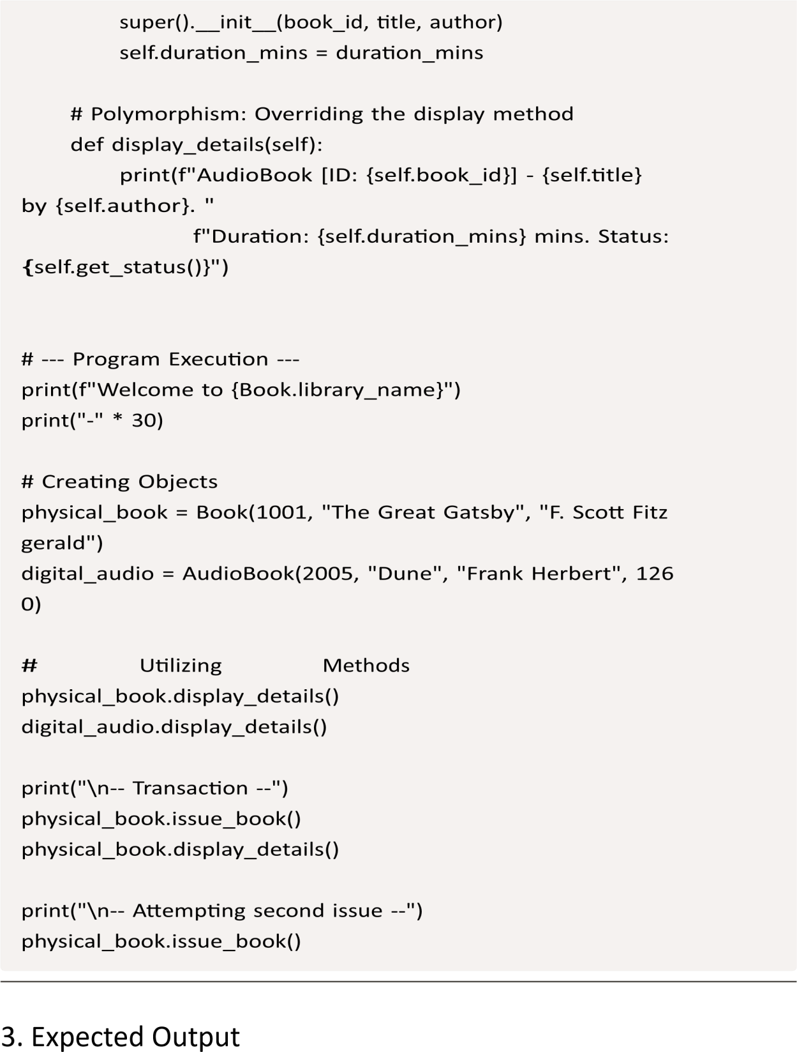
Welcome to Central City Library ------------------------------
Book [ID: 1001] - The Great Gatsby by F. Scott Fitzgerald. St atus: Available
AudioBook [ID: 2005] - Dune by Frank Herbert. Duration: 1260 mins. Status: Available
-- Transaction --
'The Great Gatsby' has been issued.
Book [ID: 1001] - The Great Gatsby by F. Scott Fitzgerald. St atus: Issued
-- Attempting second issue --
'The Great Gatsby' is already issued to someone else.

